**Program:**

#include<iostream.h>

#include<conio.h>

class Abc

{

int a[20],i;

int item,loc,flag;

public:

void GetData()

{

cout<<"Enter elements in array = ";

for(i=1;i<=5;i++)

{

cin>>a[i];

}

}

void Display()

{

cout<<"\nArray\n";

for(i=1;i<=5;i++)

{

cout<<a[i]<<" ";

}

}

void Search()

{

flag = 0;

cout<<"\nEnter item to search = ";

cin>>item;

for(i=1;i<=5;i++)

{

if(item==a[i])

{

loc=i;

flag=1;

break;

}

}

if(flag ==1)

{

cout<<"Item found at location="<<loc;

}

else

{

cout<<"Item not found";

}

}

};

void main()

{

clrscr();

Abc a1;

a1.GetData();

a1.Display();

a1.Search();

getch();

}

**Output 1:**

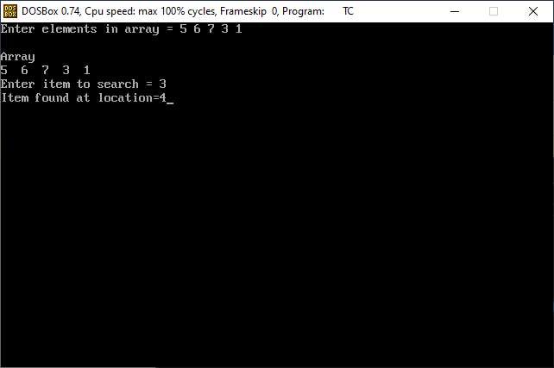

**Output 2:**

